[Google Cybersecurity Professional Certificate](https://www.coursera.org/google-certificates/cybersecurity-certificate" \l "courses)  
  
[Google IT Automation with Python Professional Certificate](https://www.coursera.org/google-certificates/cybersecurity-certificate#courses)  
  
[Career Forward](https://www.hiringourheroes.org/career-services/education-networking/career-forward/) --- [Intro Video](https://www.hiringourheroes.org/resources/google-career-forward-2022/)

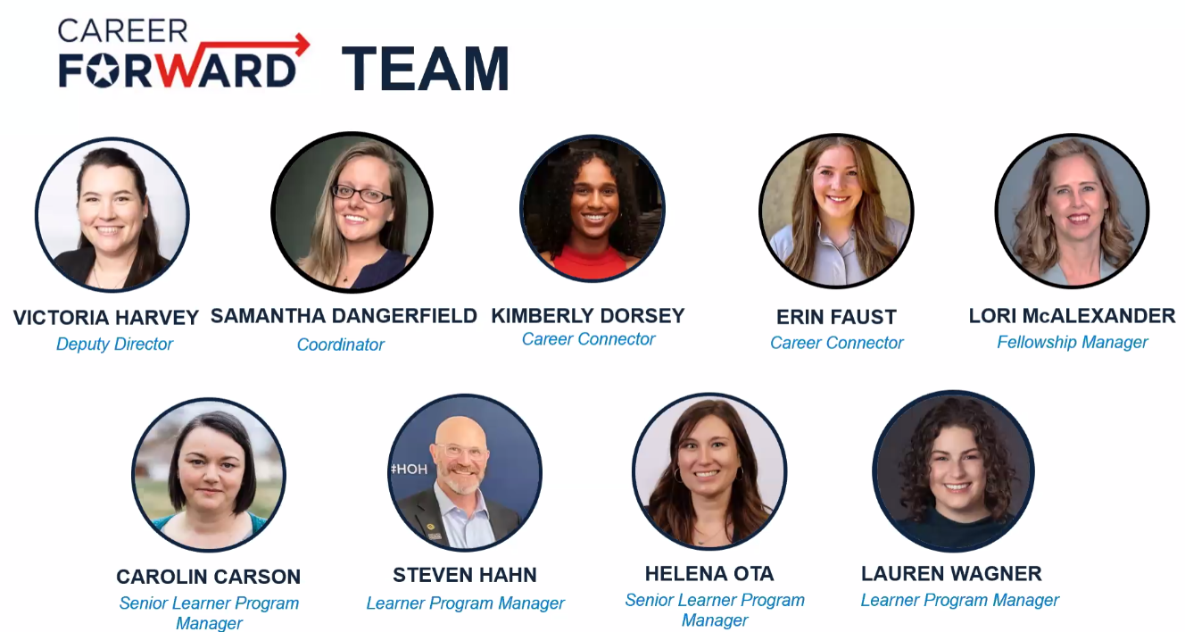

- Goal of program is upskilling/reskilling through Google Certs and to find success with employers  
- Receive a year subscription to Big Interview.com – 1 year AI interview website  
- Invite to Career Circle – Job board for Google Career Certs, community, etc…

**Part One – Reskilling/Upskilling:**

- 6 months to complete certificates  
- Can attend weekly resource seminars  
- Need to complete 1 full course within first month of program (can transfer in from personal certification) and 4 courses by end of month 3

- Post Course Survey - <https://www.hiringourheroes.org/career-services/education-networking/career-forward/post-orientation/?orientationdate=02/03/2025>

- If you do not hear from our team by 5pm ET tomorrow, please contact our team at [HOHcareerforward@uschamber.com](mailto:HOHcareerforward@uschamber.com) at that time.

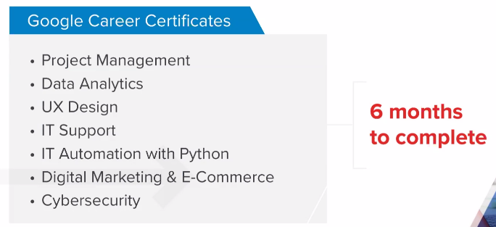

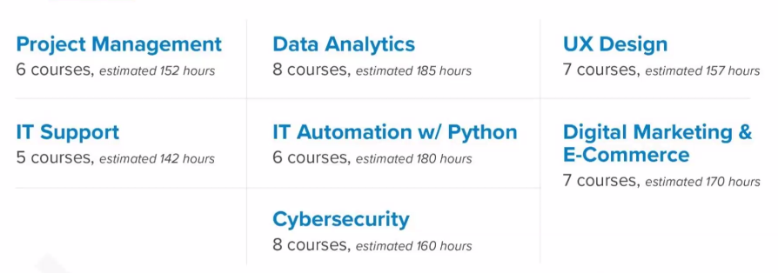

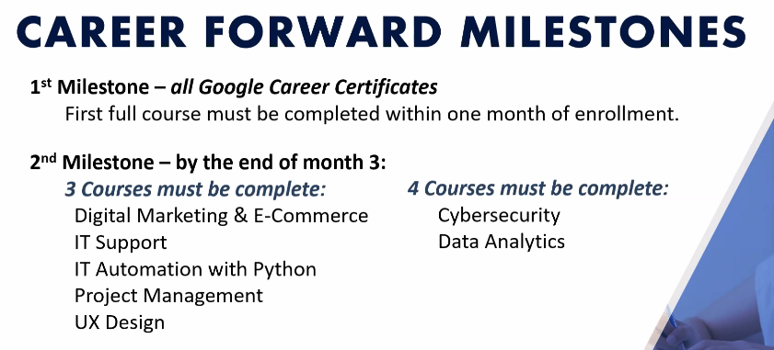

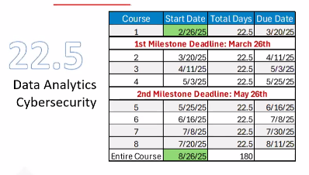

- [American Corporate Partners](https://www.acp-usa.org/) = Great Mentorship site  
- [Grow with Google](https://grow.google/certificates/) = Certificates Information  
- [Hiring Our Heroes](https://events.hiringourheroes.org/) = Roadshow/Hiring Fair  
- [LinkedIn Premium](https://socialimpact.linkedin.com/programs/veterans) = Free year for veterans

**Part Two – Employment:**

- Must complete Google Career Cert  
- Most people don’t go on to part two  
- Need to move on to part two within one year of completing certificate

- Need to submit survey, have pre-screen interview with HoH, setup baseball card that will be reviewed  
- 2 Page Resume is mandatory

- Opportunity to apply for Fellowship and receive employment assistance  
- Employer Assistance = Direct Hire role, get matched up directly with employers looking for hiring

- Resume needs to be tailored specifically toward role you are looking for (i.e. Cybersecurity relevance)

- Direct Hire Assistance = submitting resume to employers and only looking for a paid position immediately

- Fellowship – 12 weeks, paid, $18/hr for 32hrs (total = $6,336, monthly $2,112)  
- Every Fellowship is a meaningful role with an intent to hire from employer (not necessarily always entry level roles)  
- March Roadmap to Part II meeting